Version History

|  |  |
| --- | --- |
| 1.0 | Added mappings for Prod-Landing template |
|  |  |
|  |  |
|  |  |

English Page Path: /content/en/us/solutions/data-center-virtualization/index

­­­­­­­­­­­­­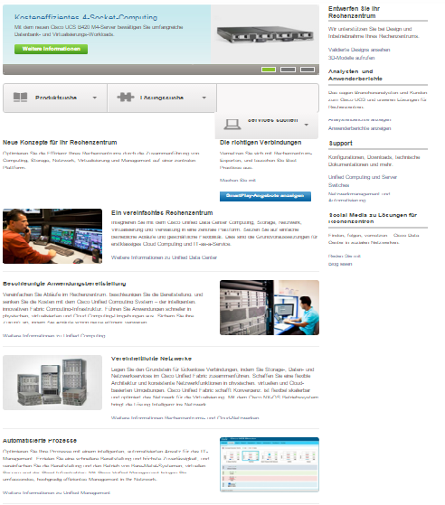

13

12

11

10

9

8

7

6

5

4

3

2

1

9

13

|  |  |  |  |
| --- | --- | --- | --- |
| 1 | /content/<locale>/solutions/<product-category>/index/jcr:content/content_parsys/overview*/layout-overview*/gd12v2*/gd12v2-left*/hero_large*/heropanel*/title |  |  |
| 2 | /content/<locale>/solutions/<product-category>/index/jcr:content/content_parsys/overview*/layout-overview*/gd12v2*/gd12v2-left*/hero_large*/heropanel*/ description |  |  |
| 3 | /content/<locale>/solutions/<product-category>/index/jcr:content/content_parsys/overview*/layout-overview*/gd12v2*/gd12v2-left*/hero_large*/heropanel*/ linktext  /content/<locale>/solutions/<product-category>/index/jcr:content/content_parsys/overview*/layout-overview*/gd12v2*/gd12v2-left*/hero_large*/heropanel*/ linkurl |  |  |
| 4 | /content/<locale>/solutions/<product-category>/index/jcr:content/content_parsys/overview*/layout-overview*/gd12v2*/gd12v2-left*/selectorbarlarge*/selectorbarpanel*/title  /content/<locale>/solutions/<product-category>/index/jcr:content/content_parsys/overview*/layout-overview*/gd12v2*/gd12v2-left*/selectorbarlarge*/selectorbarpanel*/titleurl  /content/<locale>/solutions/<product-category>/index/jcr:content/content_parsys/overview*/layout-overview*/gd12v2*/gd12v2-left*/selectorbarlarge*/selectorbarpanel*/alllinktext  /content/<locale>/solutions/<product-category>/index/jcr:content/content_parsys/overview*/layout-overview*/gd12v2*/gd12v2-left*/selectorbarlarge*/selectorbarpanel*/alllinkurl |  |  |
| 5 | /content/<locale>/solutions/<product-category>/index/jcr:content/content_parsys/overview*/layout-overview*/gd12v2*/gd12v2-left*/gd22v2*/gd22v2-left*/text |  |  |
| 6 | /content/<locale>/solutions/<product-category>/index/jcr:content/content_parsys/overview*/layout-overview*/gd12v2*/gd12v2-left*/gd22v2*/gd22v2-right*/text |  |  |
| 7 | /content/<locale>/solutions/<product-category>/index/jcr:content/content_parsys/overview*/layout-overview*/gd12v2*/gd12v2-left*/gd22v2*/gd22v2-right*/a00v1_cq/linkText  /content/<locale>/solutions/<product-category>/index/jcr:content/content_parsys/overview*/layout-overview*/gd12v2*/gd12v2-left*/gd22v2*/gd22v2-right*/a00v1_cq/linkUrl |  |  |
| 8 | /content/<locale>/solutions/<product-category>/index/jcr:content/content_parsys/overview*/layout-overview*/gd12v2*/gd12v2-left*/spotlight_large_v2*/title |  |  |
| 9 | /content/<locale>/solutions/<product-category>/index/jcr:content/content_parsys/overview*/layout-overview*/gd12v2*/gd12v2-left*/spotlight_large_v2*/description |  |  |
| 10 | /content/<locale>/solutions/<product-category>/index/jcr:content/content_parsys/overview*/layout-overview*/gd12v2*/gd12v2-left*/spotlight_large_v2*/linktext  /content/<locale>/solutions/<product-category>/index/jcr:content/content_parsys/overview*/layout-overview*/gd12v2*/gd12v2-left*/spotlight_large_v2*/cta/url |  |  |
| 11 | /content/<locale>/solutions/<product-category>/index/jcr:content/content_parsys/overview*/layout-overview*/gd12v2*/gd12v2-right*/list/title |  |  |
| 12 | /content/<locale>/solutions/<product-category>/index/jcr:content/content_parsys/overview*/layout-overview*/gd12v2*/gd12v2-right*/list/intro/paragraph_rte |  |  |
| 13 | /content/<locale>/solutions/<product-category>/index/jcr:content/content_parsys/overview*/layout-overview*/gd12v2*/gd12v2-right*/list/element_list*/listitems |  |  |